COIL Academy Announcement

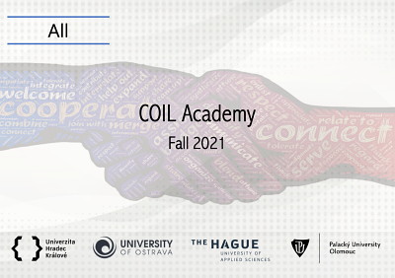
When: Select Tuesdays from 4 -5.30 PM (CET) starting Oct.12th 2021

What: 6 virtual sessions and helpdesk to help you design and deliver COIL courses with your international partners

Who: For academics from UP, OU, UHK plus Session 1 and Session 6 are OPEN TO ALL!

We are launching a joint COIL Academy (fall 2021) - a new joint online training programme of 3 Czech universities: IEI at Palacký University, Ostrava University, and the University of Hradec Králové with The Hague University of Applied Science to support collaborative online teaching and learning (COIL).

Collaborative Online International Learning (COIL) is the co-teaching of two or more teachers from universities in different countries who jointly deliver their courses. They provide the students with opportunities to gain international knowledge and to learn in an international classroom without the necessity of travel.

Lead Trainers: Dr. Reinout Klamer and Dr. Jos Beelen, from The Hague University of Applied Sciences, who are experts in internationalisation and have long-term experience in COIL practice.

Who Should Participate?
The training is designed for academics from Palacký University, Ostrava University and the University of Hradec Králové to help them design and deliver quality COIL courses with their current or prospective international partners. We encourage academics to attend the training in small groups or tandems with their colleagues from the same discipline/department/faculty so that they may help each other in the process of building up new COIL courses.

We also encourage educational specialists from Pedagogical Centres, team leaders and departmental heads as well as IRO staff to join the academics in the training and learn about this specific internationalization of curriculum process and support COIL from their positions.

What is the Cost?
FREE OF CHARGE for UP, UHK, OU academics (who are expected to actively participate in all sessions).

What Will You Learn?
Six virtual (90 min) sessions are tailor-made for Czech university context and will guide you through the process of designing a course involving COIL practice. During our interactive workshops, we will work in mixed teams and have both individual, team and plenary assignments and discussions.

The training will be followed by a “HelpDesk” for academics to support them after the training in practical development. The Helpdesk will be provided by IEI experts in collaboration with THUAS trainers.

The course will give participants a Certificate from the The Hague University of Applied Sciences (Research Group Global Learning) based on participation and completion of tasks for each session.

When Is It held?
Select Tuesdays from 4 -5.30 PM (CET) Oct 12th , Oct 26th , Nov. 9th, Nov. 23rd, Dec.7th, Dec. 14th
Session 1 and Session 6 are OPEN TO PUBLIC - join us and learn about COIL!!! (link will be available prior the event on iei.upol.cz)

REGISTER HERE

The training is organized thanks to long-term collaboration of IEI team and THUAS internationalization team and the great support of Czech Vice-Rectors: Jiří Stavovčík (UP), Renáta Tomášková (OU) and Leona Stašová (UHK).

For more on COIL: Watch VIDEO Here

For more information on the training contact: eva.janebova@upol.cz

With well wishes on behalf of the organizing team,

Eva Janebová, Ph.D.
Director of the Institute for Excellence in Internationalization
Palacký University Olomouc

